**DAILY ONLINE ACTIVITIES SUMMARY**

|  |  |  |  |  |  |  |  |  |
| --- | --- | --- | --- | --- | --- | --- | --- | --- |
| **Date:** | **28-05-2020** | | | | | **Name:** | **Apoorva H P** | |
| **Sem & Sec** | **VI A** | | | | | **USN:** | **4AL17CS011** | |
| **Online Test Summary** | | | | | | | | |
| **Subject** | | **OS IA Test** | | | | | | |
| **Max. Marks** | | **30** | | **Score** | | | **24** | |
| **Certification Course Summary** | | | | | | | | |
| **Course** | **Cloud Foundations** | | | | | | | |
| **Certificate Provider** | | | **Great Learning** | | **Duration** | | | **4.5hr** |
| **Coding Challenges** | | | | | | | | |
| **Problem Statement:**  1. Python program to find digital root of a number.  2. Write a C Program to sort an array of integers in ascending order and display the sorted array and Number of passes performed for sorting. | | | | | | | | |
| **Status: Completed** | | | | | | | | |
| **Uploaded the report in GitHub** | | | | | **Yes** | | | |
| **If yes Repository name** | | | | | <https://github.com/ashaapoorva/online-coding-and-certification-course> | | | |
| **Uploaded the report in slack** | | | | | **Yes** | | | |

**Online test Detail:**

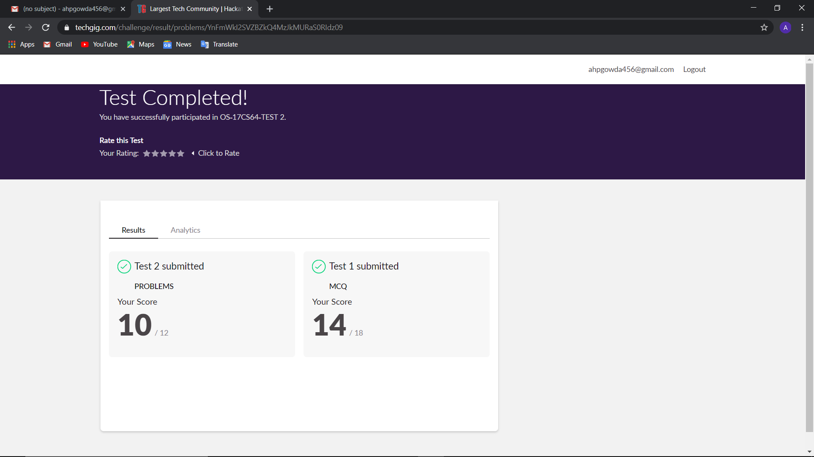

**Online Certification Details**

Modules completed:

-Introduction to virtualization

-Containers vs VMs,PaaS & Services Taxonomy

-Price Economics,Data Velocity & Distributed Computing

-Apps for Cloud & Security Model

-Infra Automation,Abstraction,Provisioning,Allied Tech

-Summarization

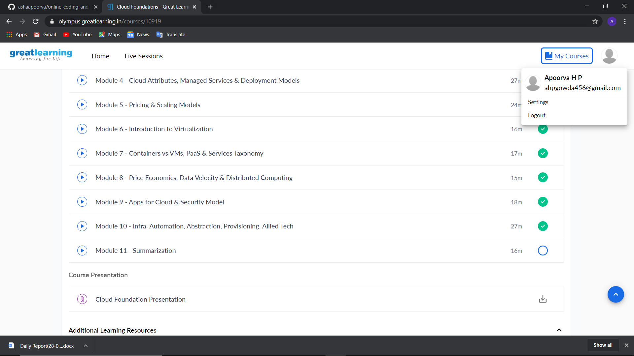

**Coding Challenge Details**

1. Python program to find digital root of a number.

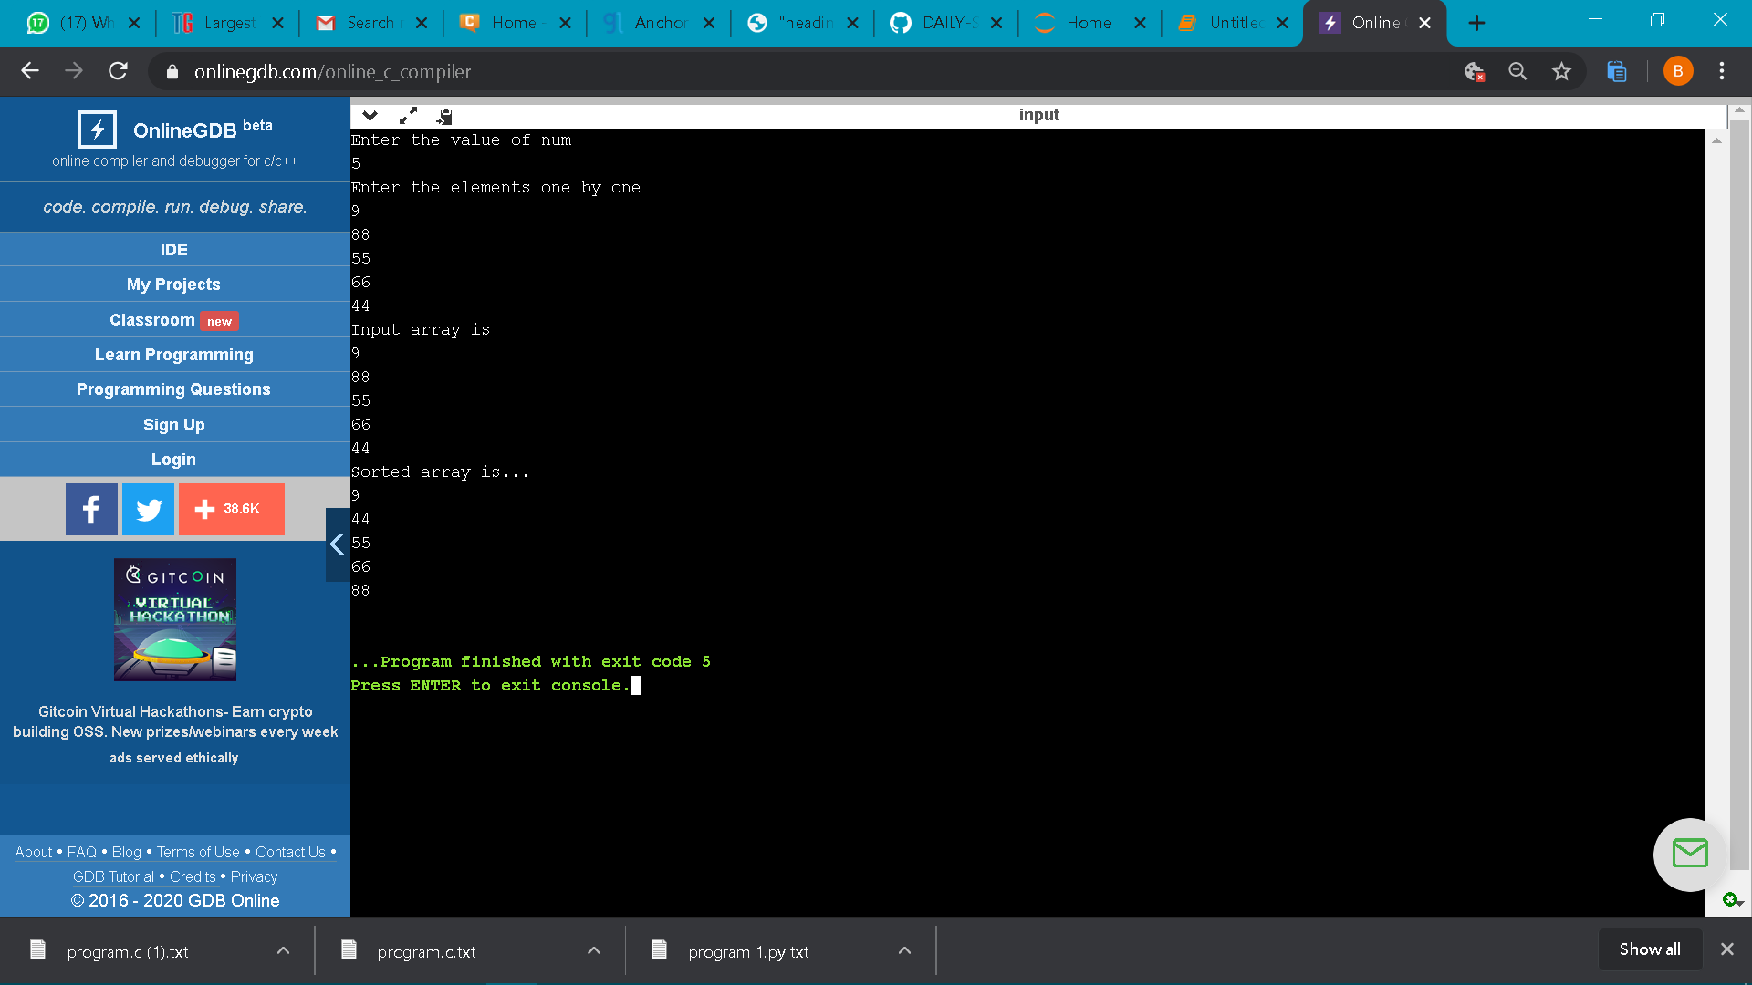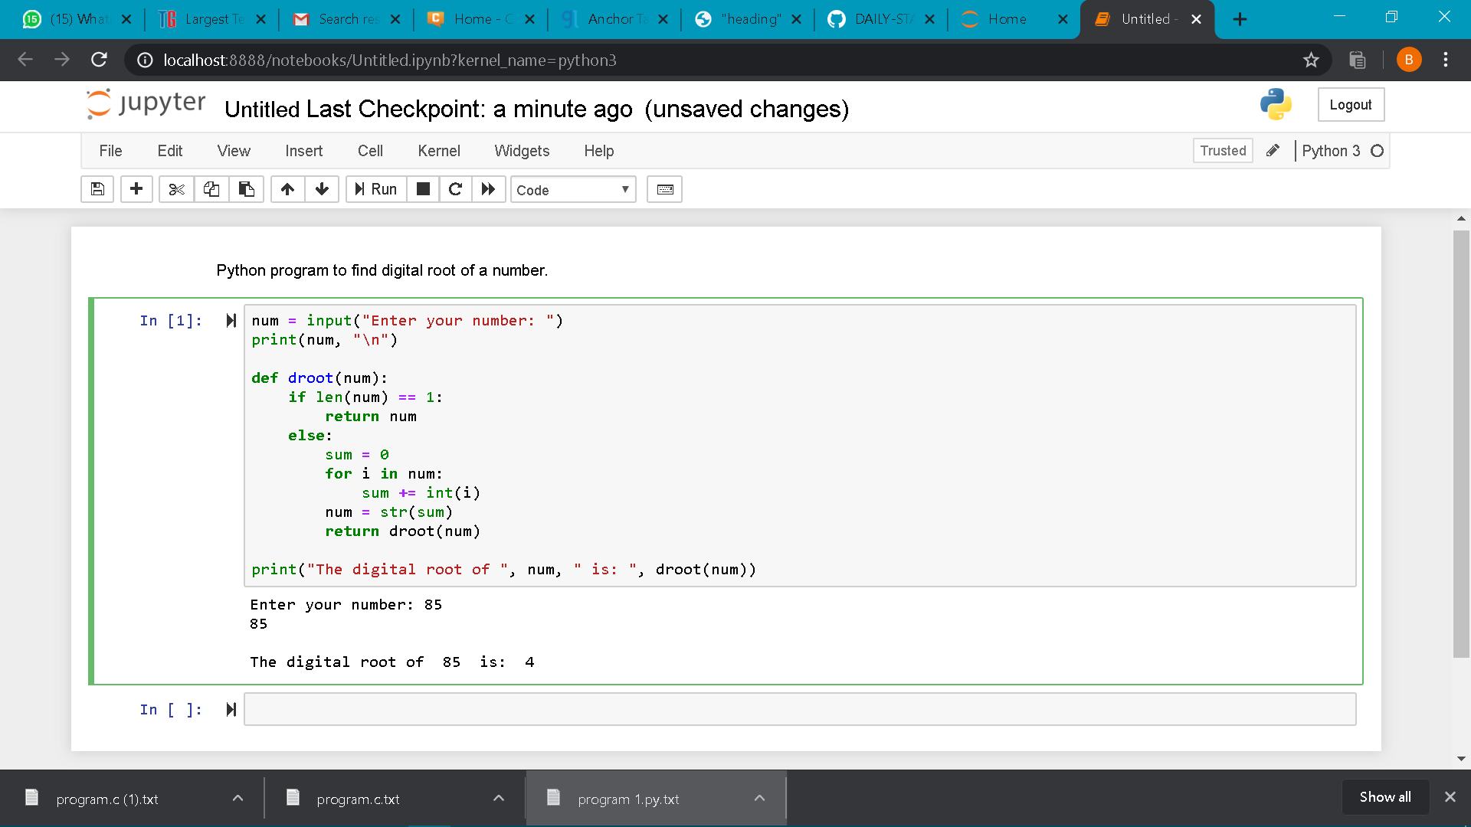  
2. Write a C Program to sort an array of integers in ascending order and display the sorted array and Number of passes performed for sorting.